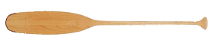
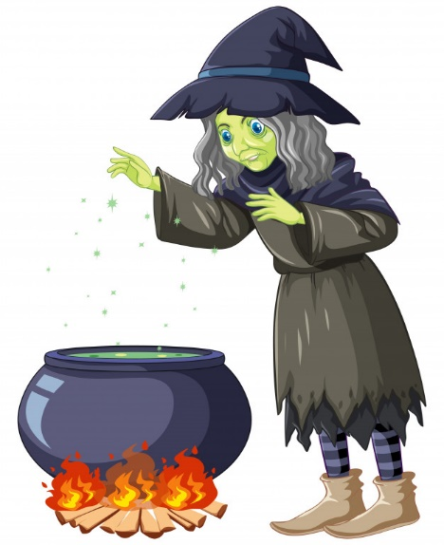
4th Annual
This Photo by Unknown Author is licensed under CC BY-NC
ESTHERWOOD PARK FEST
GUMBO COOKOFF
SATURDAY, NOVEMBER 2, 2024 - KC HALL IN ESTHERWOOD
Entry fee is $30.00 per team.
Payment accepted: Cash, Check, money order, Venmo@Estherwood-Villageof
Deadline 10/25/2024, after entry will be $40.00 per team.
RULES AND ENTRY FORM
- Gumbo must be cooked on site the day of the event.
- The ingredients are the cooks’ choice: meat, seafood, etc.
- Participants must provide all the items needed. (Utensils, small bowls/cups, tents, tables, chairs, pot, burners, propane, etc.) Water is available on site.
- Rice will be provided
- Must cook enough gumbo to serve the public.
- Gumbo must be finished cooking and ready to serve by 12:00P.M.
- Judging will begin at 12:30pm.
TEAM NAME: _______________________________________________________
TEAM MEMBERS: __________________________________________________________________________________________________________________________________________________________
I HAVE READ THE RULES AND REGULATIONS PROVIDED, AND I AGREE TO ABIDE BY ALL GUIDELINES. FAILURE TO ABIDE BY THE RULES WILL SUBJECT MY TEAM TO DISQUALIFICATION.
Signature ______________________________________
**************FOR OFFICE USE ONLY*******************
Date of Entry: _______________________ Payment Method: ___________________

Call 783-0464 if additional information is needed.

